IHE Workitem Proposal (Detailed)

Proposed Workitem: Transfer &Transport Profile
Proposal Editor:
Author  Philip DePalo, MS, NREMT-P  Department of Computer and Information Sciences  Towson University  8000 York Road  Towson, MD 21252  USA | Editor  Yeong-Tae Song, PhD  Department of Computer and Information Sciences  Towson University  8000 York Road  Towson, MD 21252  USA
Work item Editor: Philip DePalo, MS, NREMT-P
Date: November 18, 2010
Version: Version 2.0
Domain: Patient Care Coordination, Transport Medicine, Emergency Medicine, Enterprise Architecture, Healthcare Information and Management Systems Society, American Medical Informatics Association
Summary
Patients’ medical history plays an important role in their medical treatment. The role is especially important when it comes to patient transport because the transporting patient may get medical treatment during the transport and the combined medical history delivered to the physician in the receiving facility so that it can be used for real-time consultation.
LOINC and NEMSIS provide data definitions to support most of the elements required for documentation. HL7 provides for care record information.
We’d like to utilize HL7 coupled with the current PCC profiles, NEMSIS and LOINC to provide relevant patient information to support both real-time consultation from physicians and PCR update during and at completion of transport.
According to our cold calls and existing relationships with PCR vendors, there is an exceptional interest in this type of integration. A few have attempted to provide integration using HL7, but have been apprehensive giving a lack of standardized support for doing such. Any guidance in this field would be welcomed.
The IHE has the expertise and experience with developing solutions for integration issues using existing resources, but organizing them in a way for the IT community to integrate appropriately and in a methodical manner is a challenging task. This is the need the vendor community has expressed.

The Problem
There is an expectation that when a patient is transferredtheir medical records will follow them. While this is becoming true for the majority of the patient population, there is a gap for those who must be medically transported by either ambulance, helicopter or fixed wing. Developing this type of IT architecture, our profile will focus on properly aligning the concept of continuing health care records across the transport medicine environment in a seamless fashion as well as address the contribution, expectations and promises associated with a universal electronic health record as defined by Health Information Technology Standards Panel.
HITSP IS04 currently defines IHE profiles for emergency department referral (EDR) and emergency department encounter summary (EDES) [1]. Both of these profiles are geared toward the pre-hospital provider typically referred to as the 911 system. However no profile has been defined for the inter-facility providers that hold the same licensure, but handle a different type of care, usually with an expanded scope of practice as well as additional personnel resources such as a physician or nurse. This type of medicine is referred to as transport medicine. A profile needs to encompass all aspects of transfer of care and transport.
Value Statement: The need to access accurate and up to date information about each patient during all aspects of healthcare is an expectation. This falls short when it comes to moving patients and can lead to a variety of errors [3]. Adverse Drug Events are prevalent when current prescribing information and pharmacy orders are not accessible or verifiable [4]. Other similar items include allergy information, past medical history, current medical history and vital sign trending and radiology records to name a few. Patients often undergo repeat tests, CT scans and additional medication reconciliation which increases costs to the patient as well as radiation exposure and potential for medical errors.
During transport real time information will be transmitted to the receiving facility so the patient’s condition can be monitored. Physician consultation with the transport unit can then include aspects of changing current care or providing support.
Providing a standard for interoperability during transport medicine can begin to eliminate these cases and lower institutional costs as well as insurance costs. Patients will received lower doses of radiation and receive more complete care as the transport record is merged into the continuous electronic health record.

Use Cases
Current Practice:
Use Case ID: | TTP
Use Case Name: | Transfer & Transport
Created By: | Philip DePalo |  | Last Updated By: | Philip DePalo
Date Created: | 5/14/10 |  | Date Last Updated: | 10/28/1011/19/11
Actors: |  | Transport Clinicians, Sending Facility, Receiving Facility
Description: |  | Patient Transfer & Transport
Trigger: |  | Patient Requires Transfer
Preconditions: |  | - Patient requires higer level,specialty, or emergencycare  - Patient has agreed to transport risk  - Receiving facility has accepted responsibility of the patient or patient to ED
Postconditions: |  | - Patient has arrive at receiving facility  - Patient report has been given to receiving facility
Normal Flow: |  | - Patient needs transfer  - Receiving facility accepts responsibility for the patient or patient to ED  - Transport clinicians receive patient  - Transport clinicians receive verbal  - Transport clinicians receive “relevant” paper documentation  - Transport clinicans engage patient care and necessary treatment during transport  - Transport clinicians create proprietary electronic or paper documentation  - Transport clinicians transfer patient care to receiving facility  - Transport clinicians give verbal report to receiving facility  - Transport clinians give accompanying “relevant” documentation and proprietary transport medical record if paper based or no record if electronic.
Exceptions: |  | - Patient that exceeds the capabilities of the transport clinicians may reroute to closest medical facility  - Emergent transfers may lack essential “relevant” documentation
Business Rules: |  | - Physician transfer of patient care and admission

As shown in the above use case there is a lack of information transfer. There is even potential for no information transfer in emergent cases, where patient medical information is crucial since emergent cases are typically associated with higher acuity patients.
Radiology study results for the patient from sending facilities are often repeated because of lack of receiving facility confidence in the quality of the study or inability to integrate it into the current imaging database of the receiving facility.
As seen in step 10 in the above use case, there is a loose paper based record or no record in case of proprietary electronic documentation. In cases of short transport time, lack of data may not be essential, but in cases of longer transports such as fixed wing aviation which could span over several hours and the associated data during transport may not be accessible to the receiving facility for their tools in diagnosing and treating the patient.
Proposed Practice:
Use Case ID: | TTP
Use Case Name: | Transport & Transfer Profile
Created By: | Philip DePalo |  | Last Updated By:
Date Created: | 5/14/10 |  | Date Last Updated: | 11/19/10
Actors: |  | Transport Clinicians, Sending Facility, Receiving Facility
Description: |  | Patient Transport & Transfer
Trigger: |  | Patient Requires Transfer
Preconditions: |  | - Patient requires higer level specialty, or ED care  - Patient has agreed to transport risk  - Receiving facility has accepted responsibility of the patient
Postconditions: |  | - Patient has arrived at receiving facility  - Patient report has been given to receiving facility
Normal Flow: |  | - patient requires transfer  - Receiving facility accepts responsibility for the patient or ED  - Receiving facility accesses electronic health record  - Transport clinicians receive verbal report from sending facility  - Transport clinicians receive electronic health record  - Transport clinicans engage patient care and necessary treatment during transport  - Transport clinians provide real time information to receiving facility during transport  - Transport clinicians update the current electronic health record during transport  - Transport clinicians transfer patient care to receiving facility  - Transport clinicians give verbal report to receiving facility  - Receiving facility also has access to the most up-to-date electronic health record with all treatment and care provided by transport clinicians
Exceptions: |  | - Patient that exceeds the capabilities of the transport clinicians may reroute to closest medical facility  - EHR will still be updated with the most current information
Business Rules: |  | - Physician transfer of patient care and admission

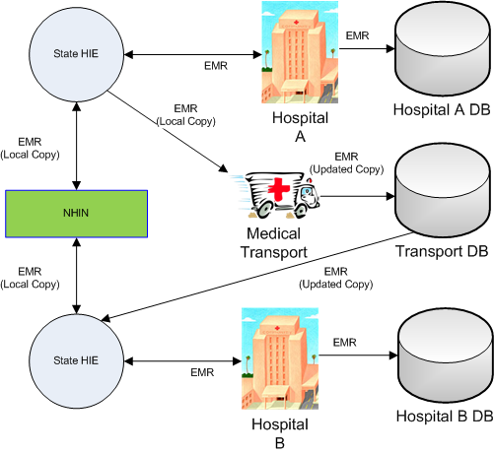
Figure 1 Inter-facility Transport Electronic Medical Record Update

Standards & Systems
Our proposed solution will make use of the National Health Information Network and State-wide Health Information Exchanges [5]. The profile will allow for HL7 messaging [6] specifically ADT, admission, discharge and transfer messages using version 3. IHE XDS-I profile that relates to cross-enterprise imaging, may apply for the imaging aspects of the transport record. The NEMSIS data dictionary standard for the national repository of EMS information may be incorporated. [7] Patient Care Devices may have some correlation to this profile as part of the attempt is to transmit real time information during transport to the receiving facility.
Additionally current profiles, namely EDES, EDR and ETC will need to be edited to incorporate or reference a complete transfer and transport profile

Technical Approach
During transport two main transactions must occur. In Part I, gathered information must be transmitted to the receiving facility physician team. This information is comprised of previous historical clinical data gathered from the Clinical Data Source and used by the Clinical Data Consumer (transport clinicians). It also comprises new information created by Content Creator (transport clinicians) and PCDs. This information is sent via the Physician Update Service to provide real time information to the patient care team at the receiving facility.
Part II reconciles all information gathered during the transport to provide as part of the Patient Care Record for the transport service and the receiving facility and transmits information to the Clinical Data Source using the PCR Reconciliation Service.
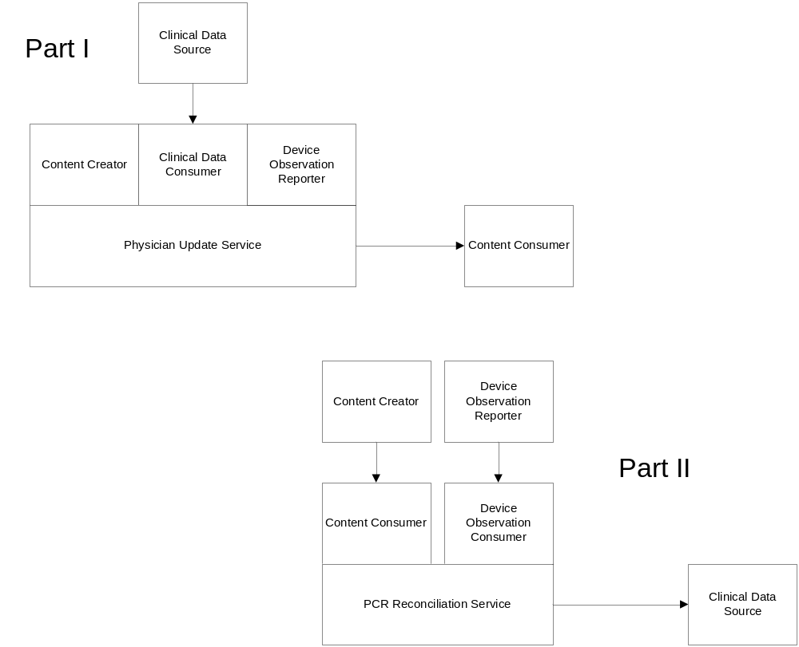
New actors
Physician Update Service
PCR Reconciliation Service
Clinical Data Consumer
Existing actors
Clinical Data Source
Content Consumer
Content Creator
Device Observation Reporter
Device Observation Consumer
New transactions (standards used)
- Report Real-Time Patient Data
This transaction is sent from the Physician Update Service to the Content Consumer. It communicates real time patient information to the receiving facility care team. This transaction could use HL7 Version 3 Standard: Care Record Topic; R1 (DSTU).
- Reconcile PCR Information
This transaction occurs upon completion or at intervals during transport and internally reconciles all gathered information into a complete Patient Care Record for both the transport service and the receiving facility.
This profile will require accessibility which can potentially be difficult in a transport environment. The ability to provide real-time information may be hindered by meteorological conditions affecting communications. Therefore the ability to implement near real-time updates would be an acceptable practice.
Impact on existing integration profiles
EDES, EDR, and ETC will be referenced or incorporated into a General Transfer and Transport Profile
The EDR can be reworded such that it applies to any physician giving a “referral” or consult to any facility or area of hospital
The EDES can relate care provided during a stay in the ED or during transport on a longer “critical care” type environment.
ETC will expand the CDA document to include additional data elements that are typically found in both Pre-Hospital and Interfacility Transport.
The current XD* suite of exchanges may not support a real time exchange of messaging for transport clinician medical direction. Another type of messaging may be more appropriate for the constant communication.
XDM is not a feasible option. XDR is not an instant solution and requires additional overhead.
New integration profiles needed
This profile would include a content component which expands NEMSIS and the current ETC profile content which currently exists and is limited given their pre-hospital scope and the expanded scope of practice found during inter-facility transport and the staffing requirements.
Defining how to exchange additional information that may be required as a detailed report of care versus a summary of care that occurred.
XDS may not be able to handle dynamic medication, allergy or problem lists. It can not handle physician orders and would require participants to be part of an affinity domain.

Breakdown of tasks that need to be accomplished
- Identify Gaps between XD* and Consultation messages
- Define content

- Identify urgency of transmitted information
- Identify similarities among different types of transfer of care and transport
- Identify USE cases for different scenarios

Risks
Lack of familiarity with IHE profile history proposes a risk to the current authors and editors. However this risk is easily mitigated with guidance and support from the PCC technical committee.
Lack of vendor support for a potentially niche environment may delay implementation of the profile. Current PCR vendors have been contacted and have expressed interest.

Open Issues
What content needs to be defined?
What PCDs will be available and consumed?

What profiles need to be incorporated or revised?
Multiple documents make reference to XD* binding by saying it is expected. However if patient is transported outside of local environment, it would be expected that they are NOT in an environment with coordinate infrastructures.
PCC TF-1 3 XDS-MS refers to summarial information, not detailed which may be required and expected as a result of the transport and transfer. Episodic are most appropriate, but still need to be revised.

Effort Estimates
The following is a list of tasks to be performed, along with an estimate of the committee effort involved in developing them.
- Prioritize the high level information items to define, and the order in which they will be prioritized to guide current and future work. (Three one hour calls)
- Identify the input information definitions that can be used to create data. (Two one hour calls)
- Identify the additional information definitions to include in PCR and Update outputs. (One one hour call)
- Identify interactions between outputs and inputs in subsequent update activities. (Committee discussion at face to face meeting)
- Identify how to integrate PCDs and PCR into the Physician Update Service (One one hour call and face to face meeting)
- Create PCC entries for output.
- Create PCC transactions. Reuse/revise existing transactions, with requirements for new entries. Review on calls and during June meeting.
- Identify what specific information needs to be consumed (2 one hour calls)

